**Production Exam 1: Chapters 1, 10, 11, 8, & 5   
108 points available – point values indicated**

**Read all instrutions before you begin to make sure you understand what is to be accomplished. You will be working in a new database, mgs_*userid*, which is “my guitar shop” and the *userid* is your logon id. There is also an MGS database which you should have privilege to read only (no updates) in the event you think there is an issue with yours.**

**NOTE: It is easy when granting privileges and building multiple files to make a mistake. It is YOUR responsibility to make sure that you have permissions for everything you need to do. If you do not, please speak to or email your instructor to straighten this out. This is not an acceptable excuse for an exam extension.**

**For all questions, do one of the following:**

* **type in your answer if appropriate**
* **use cut and paste from your putty window to show SQL and results where appropriate**
* **write your statements in an *.sql file on your local machine … that way if you have to drop/recreate your database for some reason, you will have all the statements to rerun.**
* **When asked to write a script, that means to create your SQL in a .sql file on your local machine (use Notepad++, Crimson, TextWrangler or editor of your choosing). FTP it to the server using FileZilla (or FTP client of your choosing) and then “source” it in order to execute it once you are logged on to MySQL. You will then turn that file in along with your exam.**

**If the question asks you to write an SQL statement, please show the statement and the results, including the number of rows returned from your query for full point value. If a lot of data is returned, you may clip the beginning and the end of your result set including the SQL statement. All work is to be done on dba120.abtech.edu.**

In the event that you have a problem, you can recreate your own My Guitar Shop database, mgs_*userid*. If you need to do that, please rerun all the SQL that you have aleady built so that if I need to connect to your database, I will be able to see what you have accomplished. There is a file in your home directory for creating the database and all its contents. It is already created for you, this is just in the event that you need to re-create it. It should be name “create_db_mgs_*userid*”.

These are the steps for rebuilding your database back to its original state:

* logon to the server
* logon to MySQL
* source create_db_mgs_xxxxx.sql where xxxxx is your logon, for example: create_db_mgs_brendahmcfarland.sql would be mine.
* Issue the show databases; command to make sure that the database is there.

1. Using FileZilla, or some other FTP client, move the create_db_mgs_xxxx.sql, where xxxx is your logon, over to your local machine. This file can be found in your home directory when you log on. Open for editing and familiarize yourself with the code, as this will help you to complete the exam. Complete option a or option b.

**Option a)** Write a brief narrative discussing the tables and their relationships to one another. Please discuss any business rules you glean from the design, don’t just list the keys, etc. Add anything else that you feel will be pertinent and of value to describe what you see. (15 pts)

**Option b)** Using the create_db_mgs_*userid* script, create an ERD. You can take a photo or it, scan it, type it … however you choose to submit it in moodle. (15 pts)

1. Logon to MySQL. Issue a command to show you which databases you have. (show databases). Look and see what databases are listed there. List them here or cut and paste the output from your show databases command. (2 pts).

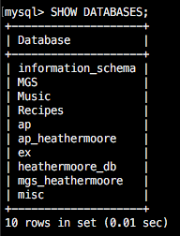

1. Set the database for your mgs_*userid* (My Guitar Shop) database as your active database. How many table are in the new database? (hint: use a variation of the show command) List them here or cut and paste the output from your putty window. (2 pts.)

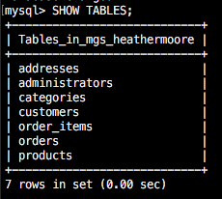

For 4 - 12, you should have two answers. You will be given the SQL to check and see that your table has been modified correctly for the second answer. (5 pts each)

Part A: Show SQL and results to solve each problem.

Part B: Show SQL and results to check/verify Part A.

1. A. Write an INSERT statement that adds this row to the categories table:

|  |  |
| --- | --- |
| category_id | the next automatically generated ID |
| category_name | Brass |

Screen Shot 2017-06-15 at 10.49.27 AM.png

B. SELECT * FROM categories;

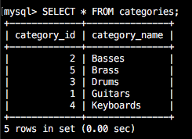

1. A. Write an UPDATE statement that modifies the row you just added to the Categories table in 4A. This statement should change the category_name column to “Woodwinds”, and it should use the category_id column to identify the row.

Screen Shot 2017-06-15 at 10.52.33 AM.png

B. SELECT * FROM categories;

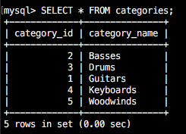

1. A. Write a DELETE statement that deletes the row you added to the Categories table in number 4A. This statement should use the category_id column to identify the row.

Screen Shot 2017-06-15 at 10.53.54 AM.png

B. SELECT * FROM categories;

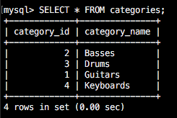

1. A. Write an INSERT statement that adds this row to the products table:

|  |  |
| --- | --- |
| product_id: | The next automatically generated ID |
| category_id: | 4 |
| product_code: | dgx_640 |
| product_name: | Yamaha DGX 640 88-Key Digital Piano |
| description: | Long description to come. |
| list_price: | 799.99 |
| discount_percent: | 0 |
| date_added: | Today’s date/time. |

Use a **column list** for this statement.



B. SELECT * FROM products WHERE product_code = ‘dgx_640’;



1. A. Write an UPDATE statement that modifies the product you added in question 7A. This statement should change the discount_percent column from 0% to 35%.

Screen Shot 2017-06-15 at 11.08.59 AM.png

B. SELECT * FROM products WHERE product_code = ‘dgx_640’;

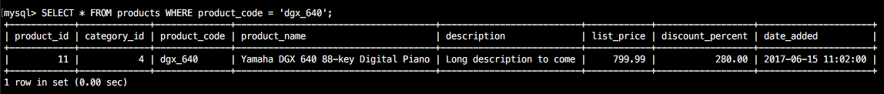

1. A. Write a DELETE statement that deletes the row for Category ID 4. When you execute this statement, it will produce an error since the category has related rows in the Products table. To fix that, precede the DELETE statement with another DELETE statement that deletes all products in this category.

Screen Shot 2017-06-15 at 11.12.04 AM.png

Screen Shot 2017-06-15 at 11.14.13 AM.png

B. SELECT * FROM categories;

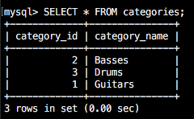

SELECT product_id, category_id FROM products;

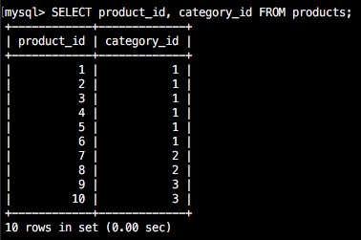

1. A. Write an INSERT statement that adds this row to the customers table:

|  |  |
| --- | --- |
| email_address: | [rick@raven.com](mailto:rick@raven.com) |
| password: | (empty string = a space) |
| first_name: | Rick |
| last_name: | Raven |

Use a **column list** for this statement.

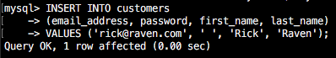

B. SELECT * FROM customers ORDER BY customer_id desc limit 1;

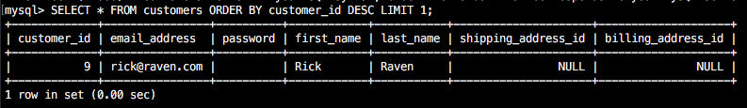

1. A. Write an UPDATE statement that modifies the Customers table. Change the password column to “secret” for the customer with an email address of [rick@raven.com](mailto:rick@raven.com).

Screen Shot 2017-06-15 at 11.22.41 AM.png

B. SELECT * FROM customers ORDER BY customer_id desc limit 1;

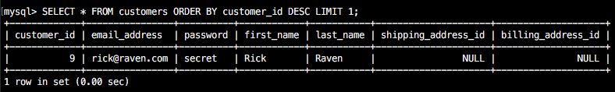

1. A. Write an UPDATE statement that modifies the Customers table. Change the password column to “reset” for every customer in the table.

Screen Shot 2017-06-15 at 11.24.05 AM.png

B. SELECT customer_id, password FROM customers;

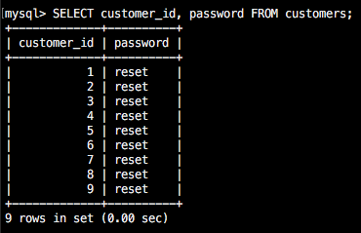

1. Write a SQL statement that adds an index (orders_order_date_ix) to your mgs_*userid* database for the order date field in the Orders table. Afterwards use the ‘SHOW INDEX FROM orders’ command to display the indexes. Cut and paste your SQL statement, as well as, output from the SHOW statement here. (7 pts)

Screen Shot 2017-06-15 at 11.28.27 AM.png

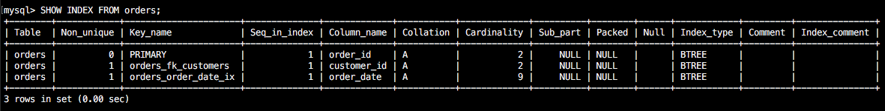

1. Write a SQL statement that adds an index (customers_zip_code_ix) to your mgs_*userid* database for the zip code field in the Addresses table. Afterwards use the ‘SHOW INDEX FROM addresses’ command to display the indexes. Cut and past your SQL statement, as well as, output from the SHOW statement here. (7 pts)

Screen Shot 2017-06-15 at 11.31.25 AM.png

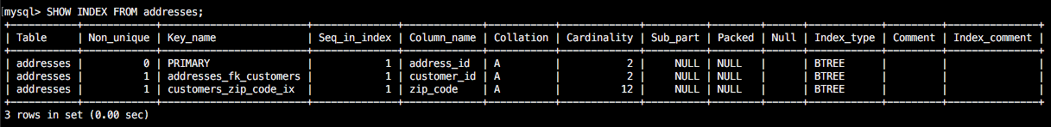

1. Write a script (exam1_question15.sql) that implements the following design in a database named exam1_*userid*, replacing userid with your logon. (30 pts)

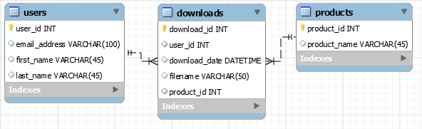

In the Downloads table, the user_id and product_id columns are the foreign keys.

Include a statement to drop the database if it already exists.

Include statements to create and use the database.

Include any indexes that you think are necessary.

Specify the utf8 character set for all tables.

Specify the InnoDB storage engine for all tables.

You will submit the file exam1_question15.sql in moodle. You shoud run (source) your scripts to create this database on the server. You have privileges for exam1_*userid* database.